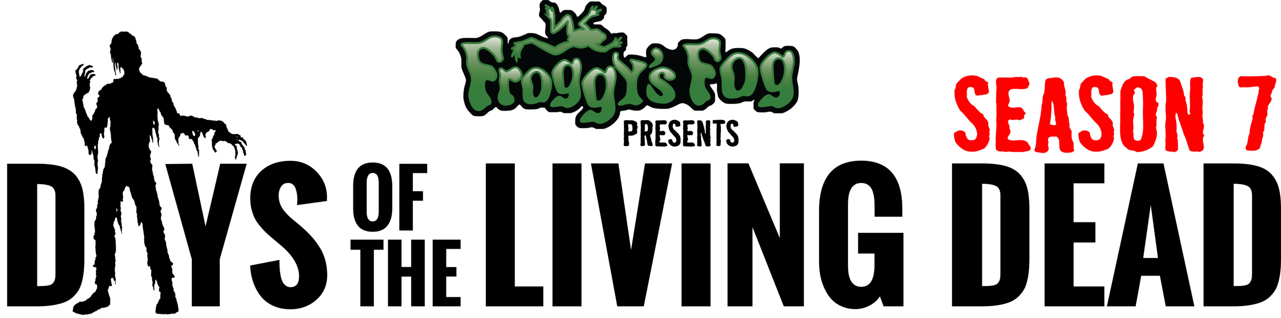

***MEDIA ALERT***MEDIA ALERT***MEDIA ALERT***
PRESS RELEASE – Days of the Living Dead, Season 7, airs 9-13-16

Days of the Living Dead was the first reality web series to go behind the scenes of the billion-dollar haunted attraction industry, following Chicago's Zombie Army Productions as they design, construct and produce two of Chicago's top haunted houses, Statesville Haunted Prison® and HellsGate Haunted House.

In past season we have seen the blood, sweat and tears that go into working at a haunted house. We have seen the high points of the Zombie Army Crew winning “Best Haunted House in America” and the low points of watching the Zombie Containment Haunted House at Navy Pier sink to the bottom of Lake Michigan. Every season has its ups and downs, gut-wrenching challenges and the joy of living the dream. The Zombie Army crew loves what they do, and they sacrifice everything to the shows that terrify Chicagoland.

Join us for Season 7 this September as we launch the biggest, baddest, meanest haunted house we've ever attempted, HellsGate. The Zombie Army is not only opening a new haunted house; they are resurrecting the Legend of HellsGate. “Since you were a kid, you've heard about the haunted house with the giant slide, the one hidden out in the woods, the one where you can win your money back, but you were never able to find it... until now! It’s HellsGate Haunted House, and it has returned.”

This Fall, don’t just go to a haunted house, go backstage at Chicago’s top haunted houses with Days of the Living Dead.

WHAT: Days of the Living Dead, A Reality Web Series that Follows Zombie Army Productions Backstage at Two of Chicago’s Top Haunted Houses.
WHEN: New Episodes air every Tuesday at Noon, September 13 – November 15
WHERE: http://www.daysofthelivingdead.com
WHO: Presented by Froggy’s Fog, Produced by Yokai Films and Zombie Army Productions
COST: Free
MEDIA: Get the Season 7 poster, graphics, photos and more at http://www.daysofthelivingdead.com/media/
CONTACT: Producer: John Laflamboy, Zombie Army Productions
Email: john@zap23.com
Website http://www.daysofthelivingdead.com
Phone: (708) 651-2323
Facebook.com/DaysOfTheLivingDead
Twitter.com/DaysLivingDead
YouTube.com/DaysOfTheLivingDead

